**Lab Activity 5: Flowchart**

Flowchart Question 1:

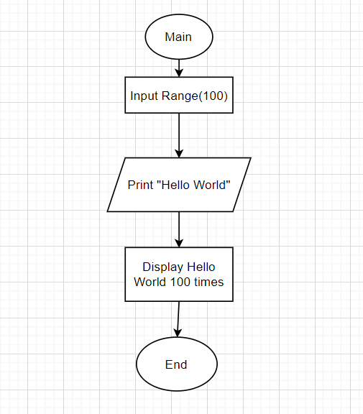

Flowchart Question 4:

